Name: Date: u-e words 1

The long (u) sound is usually represented by the u-e pattern when it comes in the middle of words, like in the words below.

Remember: Say the word aloud, then say each letter aloud as you write it e.g. 'fuse, f … u ... s ... e'

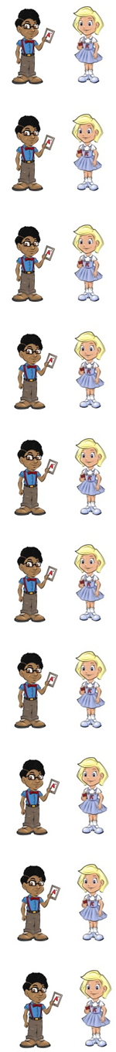
A fuse keeps a plug safe.

A cube is a 3D shape with square faces.

A tube is a round container.

Huge means very big.

A mule is a type of donkey.

A fume is a gas.

A sand dune is a hill of sand.

A kitten is cute.

If you put the TV on mute you turn the sound off.

If you confuse (con/fuse) someone, you mix them up.

Now test yourself without looking at the words and check for yourself if you got them all right. Practice writing any words that you made mistakes on again.

© www.SaveTeachersSundays.com 2013
Name: Date: u-e words 1

The long (u) sound is usually represented by the u-e pattern when it comes in the middle of words, like in the words below.

Remember: Say the word aloud, then say each letter aloud as you write it e.g. 'fuse, f … u ... s ... e'

Try to spell each word without looking at it.

A keeps a plug safe.

A is a 3D shape with square faces.

A is a round container.

means very big.

A is a type of donkey.

A is a gas.

A sand is a hill of sand.

A kitten is .

If you put the TV on you turn the sound off.

If you someone, you mix them up.

Now check for yourself if you got them all right. Practice writing any words that you made mistakes on again.

© www.SaveTeachersSundays.com 2013

